Congratulations!

The birth of a child is one of the most amazing experiences of life.
Ok, you’ve got sleepless nights, feeding times and nappies to change… But most parents also describe the birth of a child as life-changing, and the beginning of an amazing new journey as a family!

When faced with the wonder of a newborn baby, many new parents talk about having a strong desire to say thank you to God, both for a safe delivery and the privilege of parenthood. For many parents this then leads them to come to church, exploring a service of baptism or thanksgiving.

We make all sorts of decisions every day for our children. What they wear? What they eat? Who looks after them? We make these choices because we love them, we want the best for them, and we want them to have the best possible start in life. Thinking about a service of baptism or thanksgiving is also about making good choices for our children. Just as we want them to be physically safe and well, so too spiritually we want the best for them, and so make choices on their behalf. This choice is about putting God at the centre of the child’s life, and at the centre of our own lives. It is the beginning of a spiritual journey for the child, with the hope that the child will follow Jesus all of his or her life.
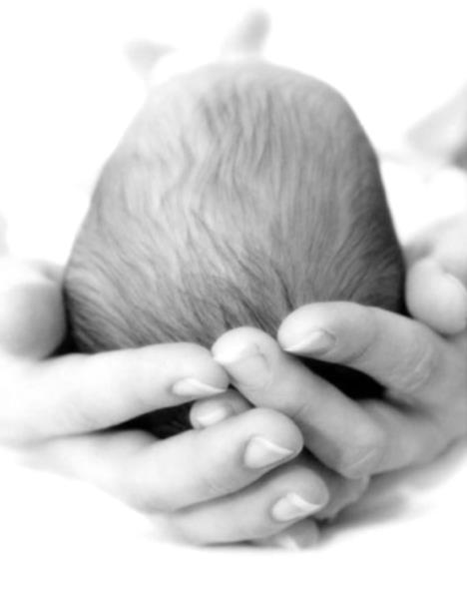
As a church we want to help you make these choices really well…

Holy Trinity contact details

Rector: Revd Richard Coldicott
t. 01273 967598
e. rector.holytrinityhpp@gmail.com

Associate Vicar: Revd Debbie Beer
t: 07530 039299 e: revdebbiebeer@gmail.com

Church Office Administrator: Clare Levin
t: 01273 835109 e: hurstparishoffice@gmail.com

www.holytrinityhpp.org.uk

Step One - saying Welcome!
The first step is for you to come along to a morning service at Holy Trinity. This is also an opportunity for you to ‘check out’ the local church family of which you’re looking for your child to be a part.

Please check our website for the latest on service times, but usually every Sunday at 9.30am there is a Holy Communion service which lasts a little over an hour, followed at 11am by a 50-minute lively family-friendly service with great content for adults and children. We love children at Holy Trinity and aim to make our Sunday services welcoming for families.

At the end of the service do say hello and introduce yourselves to one of our clergy or lay leaders, and we can then arrange to come and visit you…

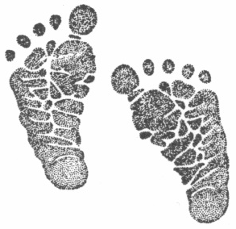
Step Two – different ways to start the journey…

The next step is to meet with one of our clergy who usually visit families in their home, to get to know you and to explore the best way forward for you.

We can offer…

A Service of Baptism

This is an opportunity to present your child to become part of the church family. The parents and godparents make commitments to follow God and put Jesus first in their lives ‘on behalf’ of the child, until such a time as the child can make a decision for themselves. (This is what confirmation is) They promise to pray for the child and to bring them up in the life of the church. The child is baptised in water – a sign and symbol of forgiveness, new beginnings and God’s power in our lives.

A Service of Thanksgiving

This is a great opportunity to give thanks to God for the gift of your child, and to pray for God’s blessing on your child. You may like to consider a Thanksgiving service if you do not feel able to say the Baptism promises. If you decide you would like your child baptised in the future, this can be arranged for you.

Step Three – good to go!

Once you’re feeling ready then we agree a date for the service itself. This date is decided between a member of the clergy team and you as a family, so please don’t book party venues or family commitments until this date is confirmed with us!

Because baptism is a sign of becoming a member of the church, and you will be promising to bring your child up in the life of the church, they happen when the church family are gathered. So baptisms can happen on Sunday mornings during our weekly 9.30am Holy Communion service or 11am family service.

Timings for Thanksgivings can be more flexible as there is no need for them to be during a church service – talk with one of our clergy, but as for baptisms, please don’t book party venues or family commitments until this date is confirmed with us!

Step Four – keep going!

Baptism and thanksgiving are beginning, not an end – an introduction to the Christian faith and God’s family here at Holy Trinity. We hope having come to us for baptism or thanksgiving you will continue to join us on Sundays, and we will do all we can to help you on the road of faith…

Heavenly Father,
our Creator and Sustainer,
we thank you for the wonder of new life.
We thank you for these children
and the precious gift they are to their families. We pray for your blessing on them.
May they know your love for them,
and your presence with them,
now and in the years ahead,
through Jesus Christ our Lord.
Amen.

Child
Baptisms
&
Thanksgivings

@

